**Підсумкова контрольна робота**

**« Тварини в небезпеці».**

* + 1. *9A Хоменко А.Ю.*

1. **Доповніть речення**

**ultraviolet generator natural tree   
 factory climate reduce oil  
 health sprays future**

1. A machine that makes electricity.
2. We have to find ways to ... pollu­tion.
3. Oil, coal, wood, air and water are all resources.
4. Many people in cities now have ... problems.
5. ... is a thick, black liquid that comes from the ground.
6. The special type of oxygen around the Earth is important because it stops... radiation.
7. Many aerosol... destroy the atmos­phere.
8. A place where they manufacture things.
9. We must change the way we live. We have to think about the ....
10. Many scientists say that the ... is changing.
11. Answer the questions and ask your partner.

|  |  |  |
| --- | --- | --- |
|  | You | Your partner |
| 1) Are you satisfied with the cleanness of the environment you live in? |  |  |
| 2) What environmental problems do you face in the place you live in? |  |  |
| 3) Have you ever taken part in solving the problem of environmental pollution? |  |  |

1. Look at the picture and describe it. ( 5-10 sentences)

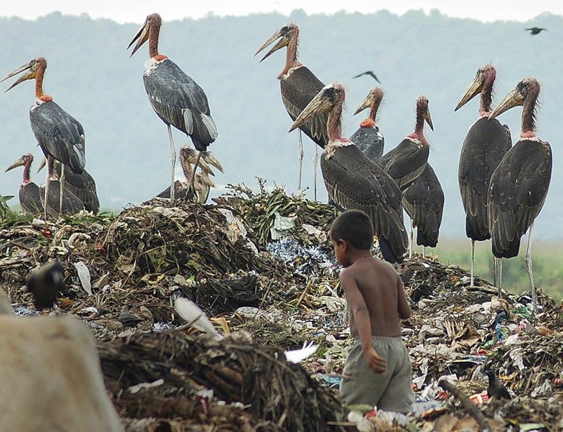

**Home work**: Виконайте контрольну роботу і надішліть на первірку.